Milestone 3: Create onChange Client Script
Description
1.Navigate to Client Scripts:
Go to System UI → Client Scripts.
2.Click New to create a new Client Script.
3.Fill in the details:
- Name: Auto set urgency for high impact – clearly shows the purpose.
- Table: Incident – the script runs only on Incident records.
- Type: onChange – executes when a field value changes.
- Field name: Impact – triggers the script when Impact is updated.
- Active: true – ensures the script runs immediately.
4.Paste the script in the script editor section.

function onChange(control, oldValue, newValue, isLoading) {
if (isLoading || newValue == '') {
return;
}

if (newValue == '1') {
g_form.setValue('urgency', '1');
g_form.addInfoMessage('Urgency set to High for High impact incident.');
}
}

5.Click Submit to save the Client Script.
6.Verify: Open an Incident record and change the Impact field to High. The Urgency field should update automatically
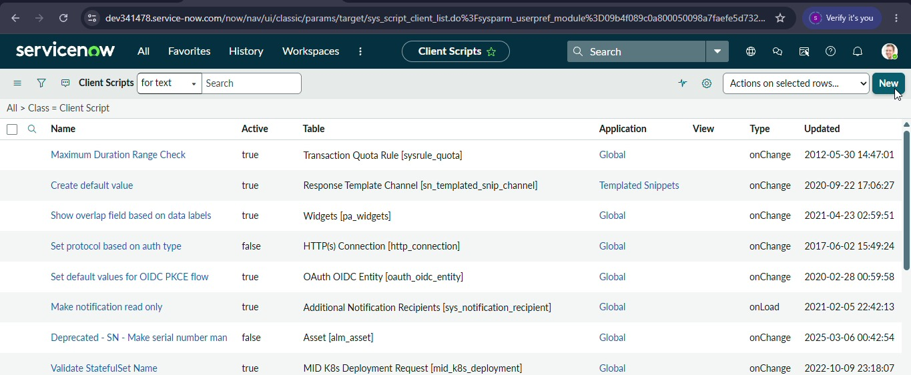
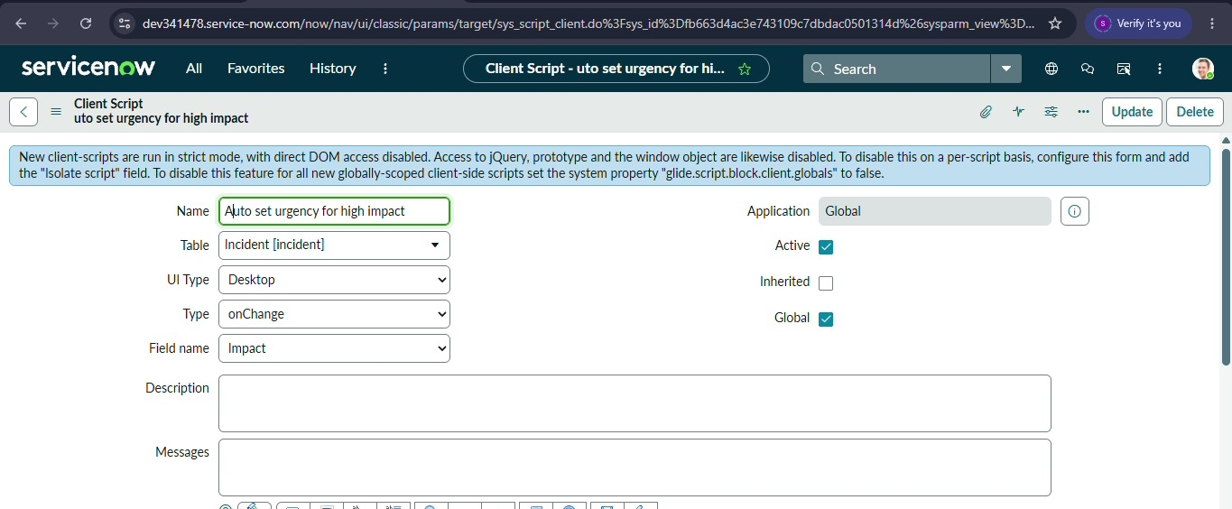

7.Click Submit.

